|  |  |
| --- | --- |
| No. of Pages | **6** |
| No. of Questions | 7 |

**Department of Computer Science and Engineering**

**FINAL EXAMINATION FALL 2017**

**CSE421/EEE 465: Computer Networks**

**Total Marks: 100 Time Allowed: 2.5 Hours**

* Answer **Any** **Five (5)** questions out of **Seven (7)** questions.
* Figure in bracket [] next to each question indicates marks for that question.

###### Question No. 1

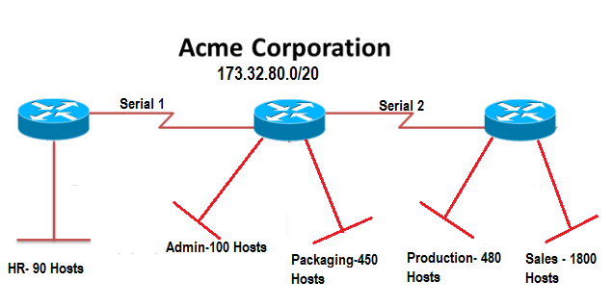

**Figure No. 1**

1. Suppose Acme Corporation is given a block **173.32.80.0/20.** But it needs five sub networks and two more for the Serial Links as shown in **figure no. 1**. Show how you can have 7 more subnets out of the original network address as per host requirements. Do not forget to show basic calculations and your final subnet addresses should be in dotted decimal notation. [9 marks]
2. Refer to **figure no.2** below, [4+2+2 marks]
   1. Create a static route for the network 20.20.20.0/24 in Router R1 and a default route in Router R3.
   2. Write the commands that will allow the network administrator create a backup path in Router R1 to the Internet? And what is it called?
   3. What is needed in Router R2 so that hosts attached to Router R2 can have access to anywhere?

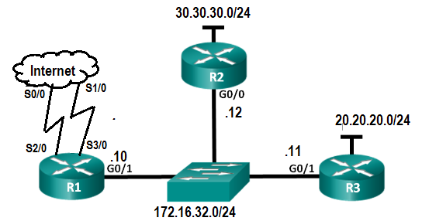

**Figure No. 2**

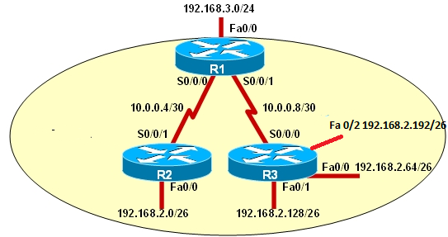

**Figure No. 3**

1. Refer to the above **figure no. 3**, a summarized static route has been configured in Router R1

**R1(config)# ip route 192.168.2.0 255.255.255.0 s0/0/1**

This command creates a problem, what is it? [3 marks]

###### Question No. 2

1. Which two switch forwarding methods require the entry and exit bandwidth to be same and why? [2+3 marks]
2. Refer to **figure no. 4** below; switch SW1 receives two frames simultaneously from the port Fa0/2. What will the switch do with these two frames and what changes will occur in the mac address tables of both the switches? [3+2 marks]

|  |  |
| --- | --- |
| Dest:FFFF:FFFF:FFFF | Source:0200:2222:2222 |

Frame 1

|  |  |
| --- | --- |
| Dest:0200:4444:4444 | Source:0200:3333:3333 |

Frame 2

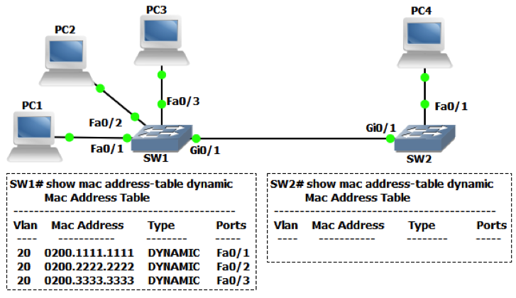

**Figure No. 4**

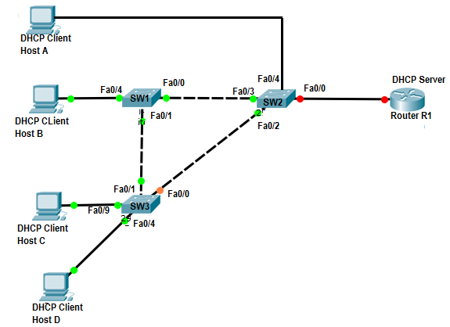

**Figure No. 5**

1. Refer to the **figure no. 5**, name the switch and the ports where we have to apply the command “ip dhcp snooping trust” to prevent the DHCP spoofing attack? [4 marks]

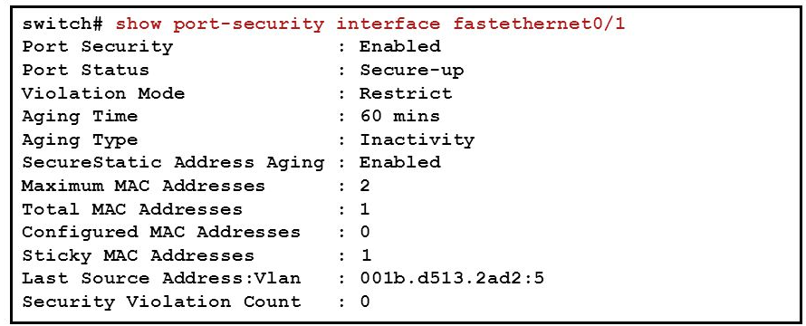

**Figure No. 6**

1. Refer to the output shown in **figure no. 6** (sticky mac addresss is enabled) and answer the following questions. [2+3+1 marks]
   1. A PC with the mac –address 1234:1234:1234 plugs into this port and tries to send a frame, what will happen?
   2. Then another PC containing mac-address ab24:1111:2345 connects to this interface and turns the switch off and on again. Then he tries to send a frame, will he be able to or not, explain briefly?
   3. What is the status of the port after all the above actions?

###### Question No. 3

1. What is the effect of the command “SW1(config)#delete vlan 1”? If the default VLAN is the management VLAN what kind of traffic will it carry? [2+2 marks]

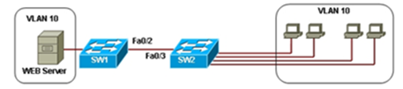

|  |  |
| --- | --- |
| **SW1#show int fa0/2 switchport**  Name: fa0/2  Switchport: Enabled  Adminstrative Mode: Desirable  Operational Mode: Trunk  Administrative Trunking Encapsulation: dot1q  Operational Trunking Encapsulation: dot1q  Negotiation of Trunking: On  Access Mode VLAN: 1 (Default)  Trunking Native Mode VLAN: 10  Trunking VLAN Enabled: 1-2  ***<outout omitted>*** | **SW2#show int fa0/3 switchport**  Name: fa0/2  Switchport: Enabled  Adminstrative Mode: Auto  Operational Mode: Trunk  Administrative Trunking Encapsulation: dot1q  Operational Trunking Encapsulation: dot1q  Negotiation of Trunking: On  Access Mode VLAN: 1 (Default)  Trunking Native Mode VLAN: 100  Trunking VLAN Enabled: 1-4  ***<outout omitted>*** |

**Figure No. 7**

1. Refer to **figure no. 7** above. [3+2 marks]
   1. What are the reason/s that explain why none of the workstations of the same VLAN are able to access each other?
   2. What happens if we change the Administrative Mode of the interface fa0/2 of the switch SW1 to “dynamic auto”?
2. Refer to the commands and topology shown in **figure no.8** , [4+2 marks]
   1. Host 1 and Host 2 have no connectivity, why?
   2. Which ports of the switch should be in trunk mode?

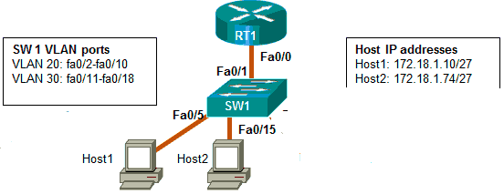

RT1(config)#**interface f0/0.2**

RT1(config-subif)#**encapsulation dot1q 20**

RT1(config-subif)#**ip add 172.18.1.254 255.255.255.224**

RT1(config-subif)#**exit**

RT1(config-subif)#**interface f0/0.5**

RT1(config-subif)#**encapsulation dot1q 50**

RT1(config-subif)#**ip add 172.18.1.75 255.255.255.224**

RT1(config-subif)#**exit**

RT1(config)# **interface fa0/0**

RT1(config-subif)#**shutdown**

**Figure No. 8**

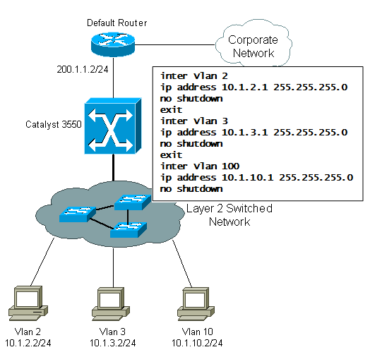

**Figure No. 9**

1. Refer to **figure no. 9** above. The inter-vlan routing is done by using a layer 3 switch. [2+3 marks]
   1. What is the effect of the command “inter vlan 2”?
   2. Some PCs are not able to communicate between different VLANs, what is the problem?

###### Question No. 4

1. Suppose that the data bytes of an original datagram of 3960 bytes which includes 40 bytes of header. The datagram is to be sent from PC1 to PC2. The datagram has to go through the network R1 –R2. The network between R1 and R2 only allows maximum data frames of 1200 bytes. The identification number of the first datagram is 111. And header length is 40 bytes. So fragment the data accordingly using the following table structure given separately. [6 marks]

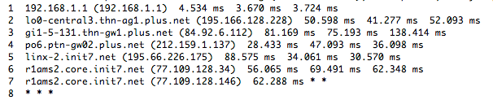

**Figure No. 10**

1. What command will produce the output shown in the above **figure no.10**? Why is there * * * at the 8th entry? To display * * *, what type of icmp message did the device receive? [2+3+1 marks]
2. The network layer header has a field that reduces congestion, which field and how? [4 marks]
3. What are the reasons behind denying ping replies from web servers, even though the web servers are up and connected? Explain one reason briefly. [4 marks]

# 

###### Question No. 5

1. Determine the compact IPv6 address of the following hosts : [3 marks]
   1. 203c: 0fdc:0000:0:0000:0: 0201:1bc5
   2. 030f:0000:0000:0000:3034:0000:0000:0023
   3. 2000:0000:0000:0000:0000:0000:0000:0000
2. How many bits represents the network part of the IPv6 address generally and what kind of information is embedded in the network part? How do we represent the subnet mask?

[1+2+1 marks]

1. Refer to the **figure no. 11** below; name the IPv6 address. Which part of the address is changed to make it a broadcast address? [1+2 marks]

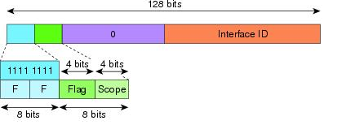

**Figure No. 11**

1. How do we handle ARP in DHCPv6? [4 marks]
2. Draw the interaction between a client, router and DHCPv6 server to explain the processes involved in State-full DHCPv6. [6 marks]

###### Question No. 6

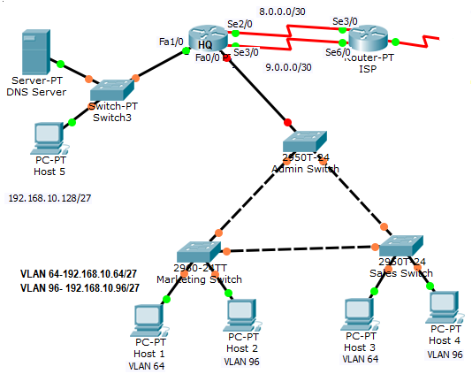

**Figure No. 12**

1. Refer to **figure no. 12**. Configure HQ router as a NAT server to dynamically assign global outside IP addresses from the NAT pool (name: **HQ_POOL) 212.16.32.130 - 135/29** to local inside packets attempting to access the Internet. The **first public address 212.16.32.129** should **be statically** assigned to the DNS server (**local address 192.168.10.130**). Then packets from the **192.168.10.128/27, 192.168.10.96/27** and **192.168.10.64/27** networks will be translated to the public addresses above using PAT. Please summarize the above private addresses to write one single access-list. [7 marks]
2. In a local network, an apache web-server is set up with only a local IP address of 192.168.10.10. All hosts of your network uses a single global IP of 210.101.10.10 to go to the Internet. How will you be able to give web access to the local web server from outside i.e the Internet? [3 marks]
3. What is the difference between DHCP automatic allocation and dynamic allocation? [4 marks]
4. Refer to **figure no.13** below; [4+2 marks]
   1. Find the reason/s why the dhcp process is not working for Host A.
   2. ARP for the DNS server is not going through the router HQ, how can we solve it?

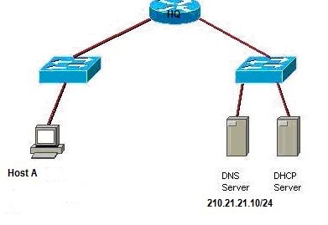

**<output omitted>**

**ip dhcp excluded-address 200.21.21.10 200.21.21.9**

**ip dhcp excluded-address 200.21.21.253**

**ip dhcp pool SALESNetwork**

**network 200.20.21.0 255.255.255.0**

**default-router 200.21.21.254**

**dns-server 200.21.21.10**

**!**

**interface FastEthernet 0/0**

**ip address 200.21.21.253 255.255.255.0**

**duplex auto**

**speed auto**

**!**

**<output omitted>**

**Figure No. 13**

###### Question No. 7

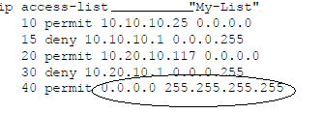

**Figure No. 14**

1. Refer to the above **figure no.14** [1+2+2 marks]
   1. What should the question mark represent?
   2. What commands should we write to deny a device with the IP address 10.20.10.100?
   3. Explain what 0.0.0.0 255.255.255.255 (highlighted by the oval) represents?
2. Refer to the **figure no. 15**, create a standard named ACL that will deny traffic from 200.0.0.0/25 Development Network and 200.0.0.128/26 Production Network to the 200.0.0.192/27 management network but all other traffic is allowed to the Management Network. Where shall you place the ACL efficiently? [4.5+1.5 marks]
3. Refer to the **figure no. 15**, write a named standard ACL that will only allow the hosts of the management network to have telnet access in the routers R1 and R2. Do not forget to place the ACLs appropriately and efficiently. [4 marks]
4. Refer to the **figure no. 15**, write an extended named ACL that will allow any network from outside to have email access only to the email server (200.0.0.226) and web access to the web server (200.0.0.227) only. No other type of access should be allowed to both of the servers. Do not forget to place the ACLs appropriately and efficiently. [5 marks]

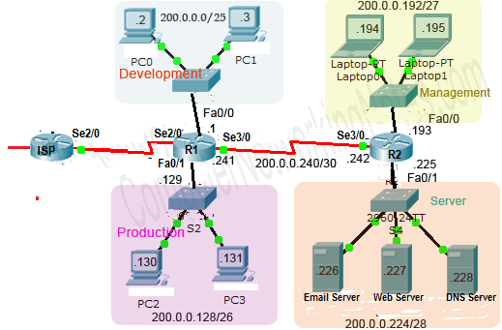

**Figure No. 15**

##### THE END